
Seeking internship,
February to May 2024
Niels
Ouvrard
Objective

As a third-year Epitech student, I hold the top position in my class in second year. I am actively seeking an internship in software development, available from February 1st to May 31st, 2024
Phone :
+33 782 021 952
Email :
niels.ouvrard@epitech.eu
Birthdate 18/07/2003
Linkedin
Github





Sport :
I've been climbing for several years.

Cinema :
As a cinema enthusiast, the works of Hitchcock, Tarantino, and Kubrick have greatly influenced me.
I am also passionate about audio-visual and have strong skills in the 'Fusion' (special effects) part of Davinci Resolve software.

Interests

Professional experience

Internship at FrenchFounders Frontend (July - December 2022) :
I have been able to create numerous web pages in Vue.js, connect them to the company's backend, and migrate many pages from Vue 2 to Vue 3.
Epitech Trainer Internship (February to June 2023 and from September 2023 to January 2024) :
Our goal is to support and train students in lower years (courses, project presentations, evaluations...).
Arcade (C++)
Creation of software for running video games (Pacman, Snake) and graphic libraries (SDL2, Ncurses, and SFML).
Antman (C)
Lossless file compression using the Huffman algorithm.
(Binary trees, linked lists)

Computer Expertise | Epitech

2021 – 2026
An average GPA of 3.8 / 4 at the beginning of the third year.
* Grade Point Average: an index of the overall quality of the student's work, ranging from 0 (unacceptable) to 4 (very good).

BACCALAUREATE | JEAN MONNET HIGH SCHOOL

2018 – 2021
With honors, (Specialization in Mathematics / Social and Economic Political Sciences / Physics - Chemistry)
Education
Completed projects
Languages :
French : Native
English : B2
Spanish : B1

Languages practiced :
  
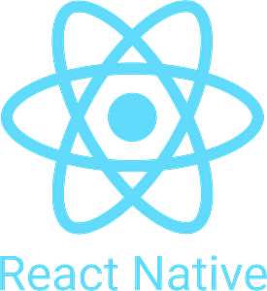
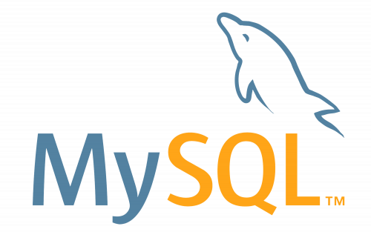

Proficiency in all operating systems.


Skills :
Software development
Algorithms
Data structures
Git, GitHub
…

